Host API Link: Swagger
https://prog7314-poe-p2-group11.onrender.com/swagger
Host API Link: Render
https://prog7314-poe-p2-group11.onrender.com/health

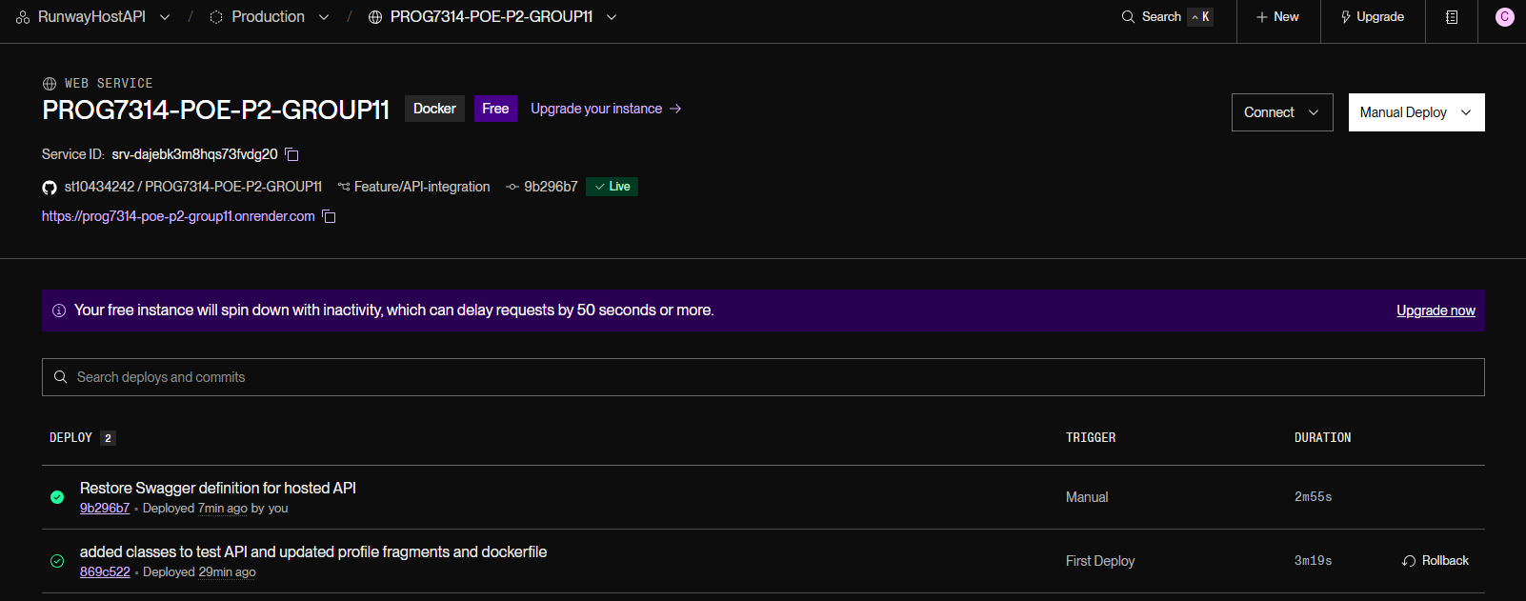
Figure 1 - Runway Host API on Render
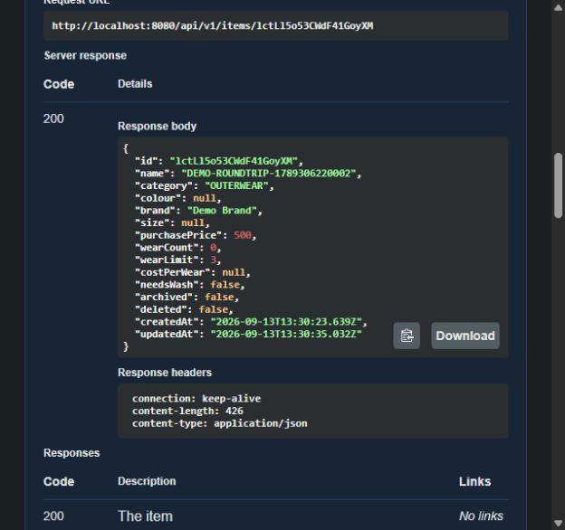
Figure 2 - Swagger item read

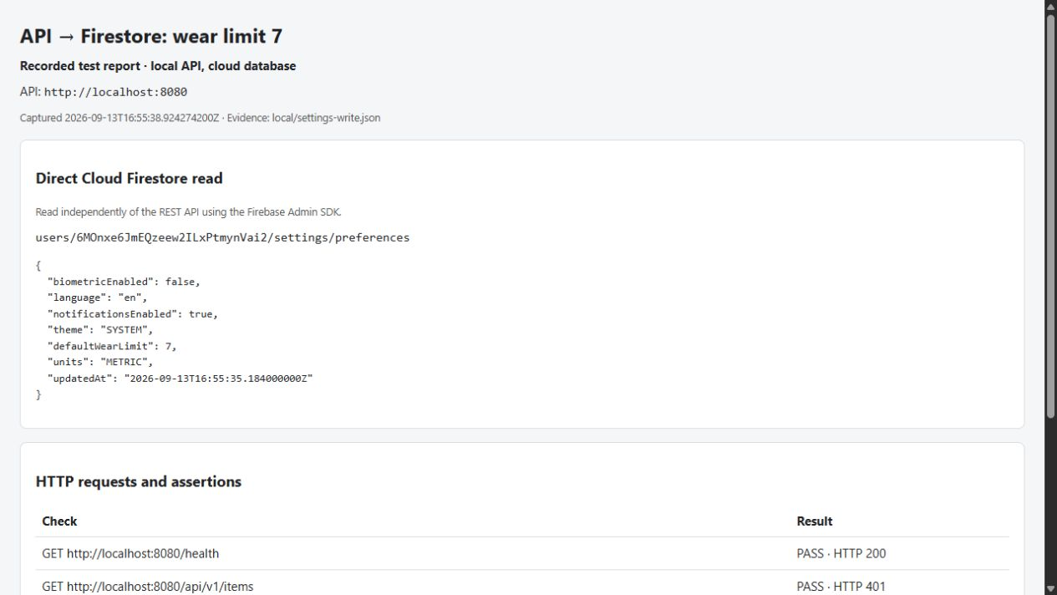
Figure 3 - Firestore read wear limit 7
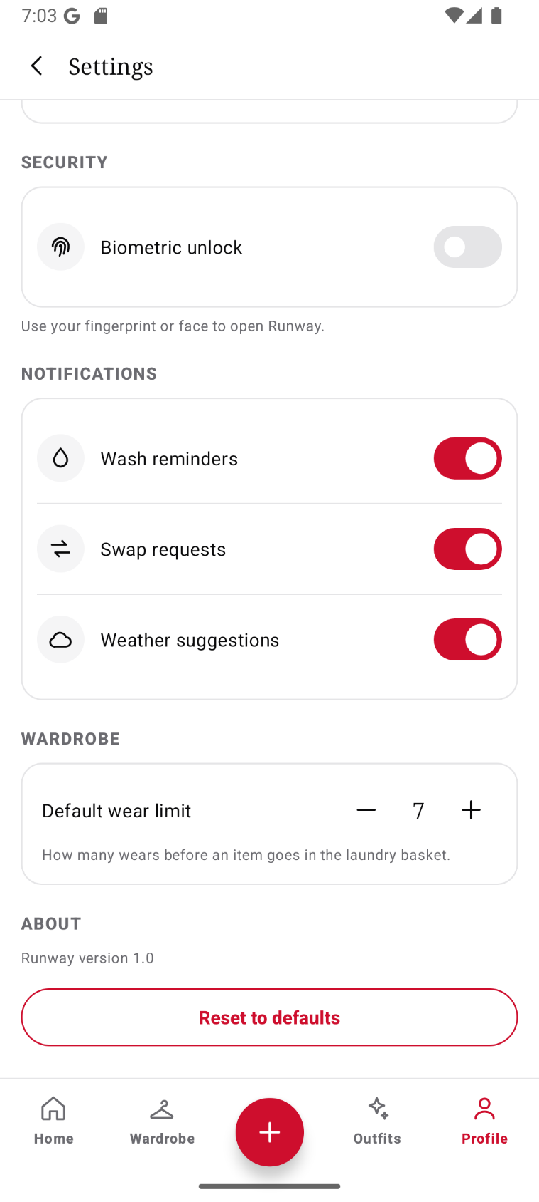
Figure 4 - android read wear limit 7
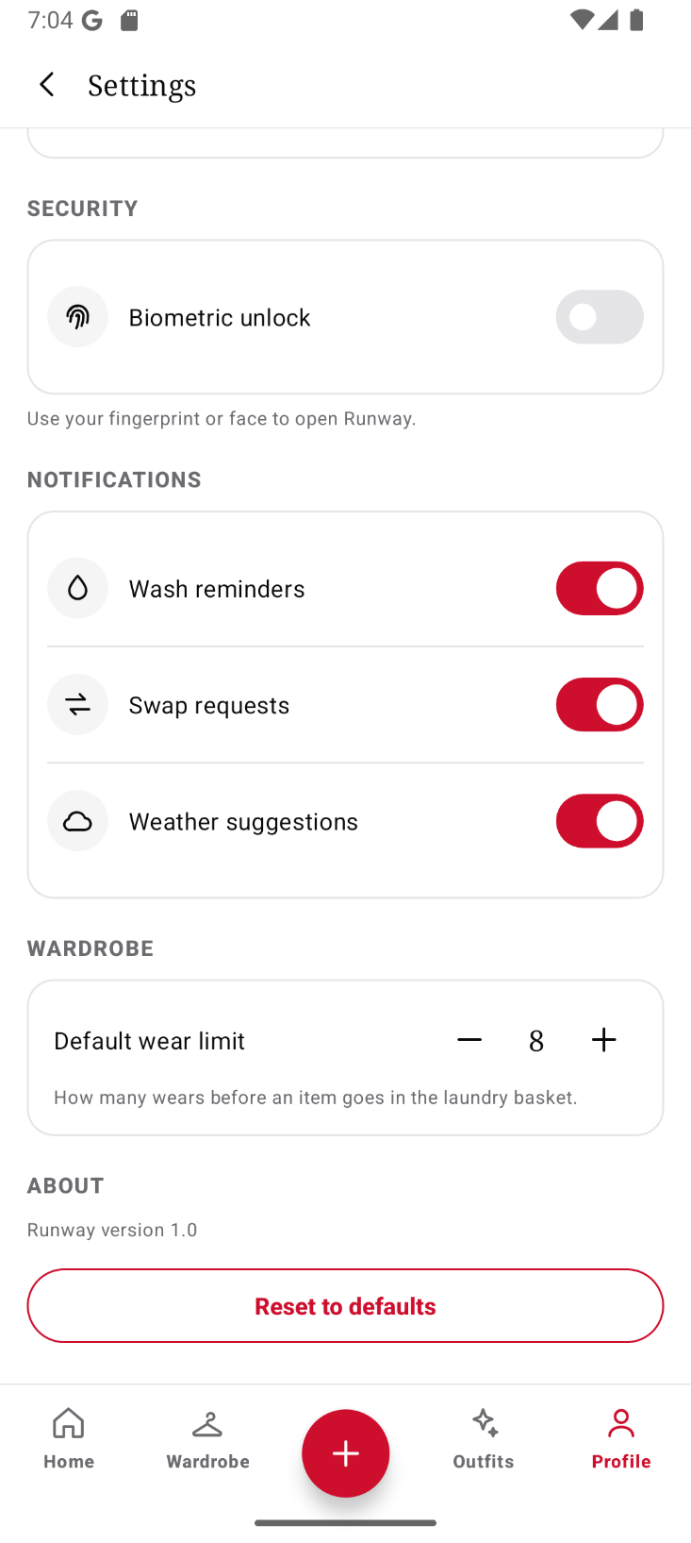
Figure 5 - android wear limit read 8
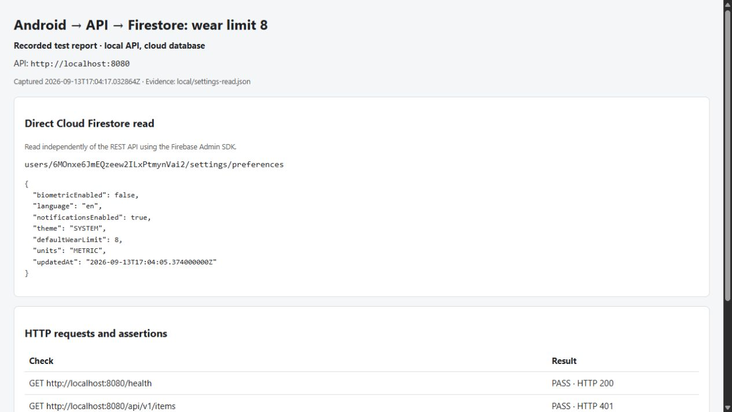
Figure 6 - firestore wear limit 8 read
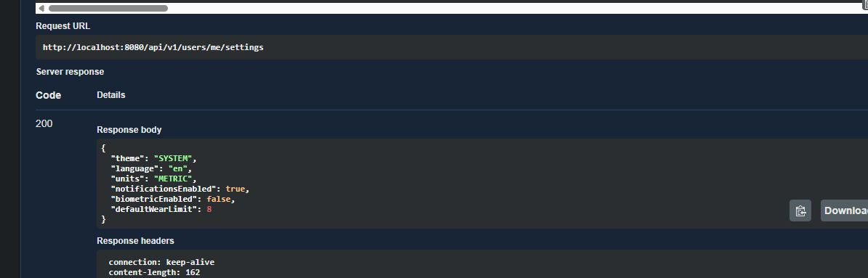
Figure 7 - swagger settings limit 8

Table of figures
Figure 1 - Runway Host API on Render 1
Figure 2 - Swagger item read 1
Figure 3 - Firestore read wear limit 7 2
Figure 4 - android read wear limit 7 3
Figure 5 - android wear limit read 8 4
Figure 6 - firestore wear limit 8 read 5
Figure 7 - swagger settings limit 8 5

